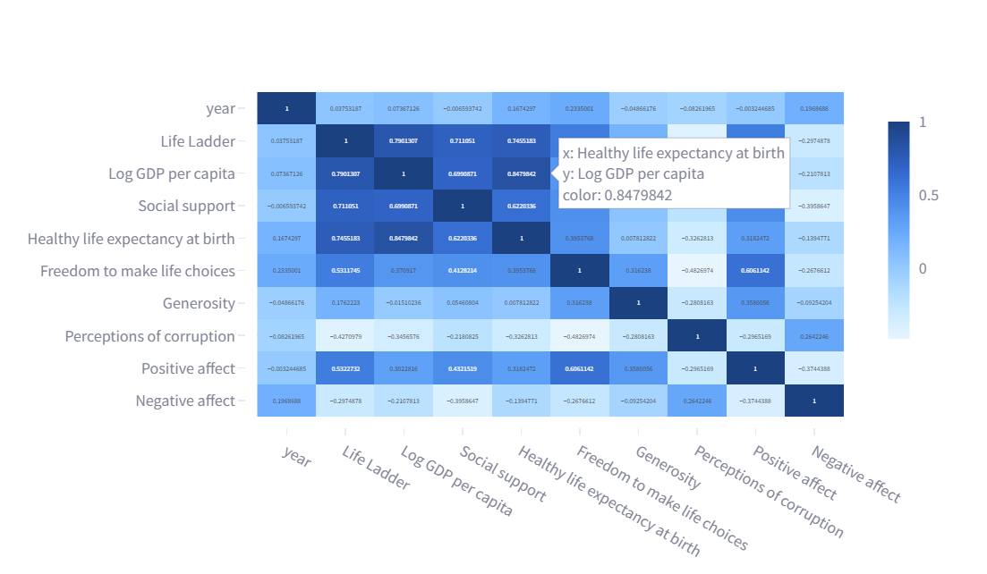

The image is a correlation matrix heatmap displaying the correlations between various factors related to the World Happiness Report. Here’s an analysis of the key elements visible in the heatmap:

**Key Elements:**

1. **Axes**:
   * Both the x-axis and y-axis list the same variables:
     + Year
     + Life Ladder
     + Log GDP per capita
     + Social support
     + Healthy life expectancy at birth
     + Freedom to make life choices
     + Generosity
     + Perceptions of corruption
     + Positive affect
     + Negative affect
2. **Color Scale**:
   * The color scale on the right indicates the correlation coefficient values, ranging from -1 to 1.
   * Darker shades of blue indicate stronger positive correlations.
   * Lighter shades of blue indicate weaker correlations.
   * Negative values indicate inverse correlations.
3. **Correlation Coefficients**:
   * The numerical values within the cells represent the correlation coefficients between the respective row and column variables.
   * Values close to 1 indicate a strong positive correlation.
   * Values close to -1 indicate a strong negative correlation.
   * Values close to 0 indicate no correlation.

**Observations:**

1. **Strong Positive Correlations**:
   * There is a strong positive correlation between **Log GDP per capita** and **Life Ladder** (0.791307).
   * **Healthy life expectancy at birth** also shows a strong positive correlation with **Life Ladder** (0.745183) and **Log GDP per capita** (0.8479842).
   * **Social support** has a positive correlation with **Life Ladder** (0.711051) and **Log GDP per capita** (0.690971).
2. **Positive but Moderate Correlations**:
   * **Freedom to make life choices** shows a moderate positive correlation with **Life Ladder** (0.511745).
   * **Positive affect** has a moderate positive correlation with **Life Ladder** (0.527732) and **Freedom to make life choices** (0.606142).
3. **Negative Correlations**:
   * **Perceptions of corruption** have a negative correlation with **Life Ladder** (-0.427079), **Log GDP per capita** (-0.345676), and **Social support** (-0.210865).
   * **Generosity** shows weak to moderate negative correlations with **Log GDP per capita** (-0.151026) and **Perceptions of corruption** (-0.280163).
4. **Weak or No Correlations**:
   * **Year** has weak or no significant correlations with most of the other variables.

**Insights:**

* The strong positive correlations between **Log GDP per capita**, **Healthy life expectancy at birth**, and **Life Ladder** suggest that economic well-being and health are strongly associated with overall happiness.
* Social support, freedom to make life choices, and positive affect also contribute positively to happiness.
* Higher perceptions of corruption are negatively associated with happiness, indicating that corruption perception can diminish overall well-being.
* Generosity's weak correlations suggest that it might have a more complex or indirect relationship with happiness compared to other factors.

This correlation matrix provides valuable insights into the relationships between different variables affecting happiness and well-being.

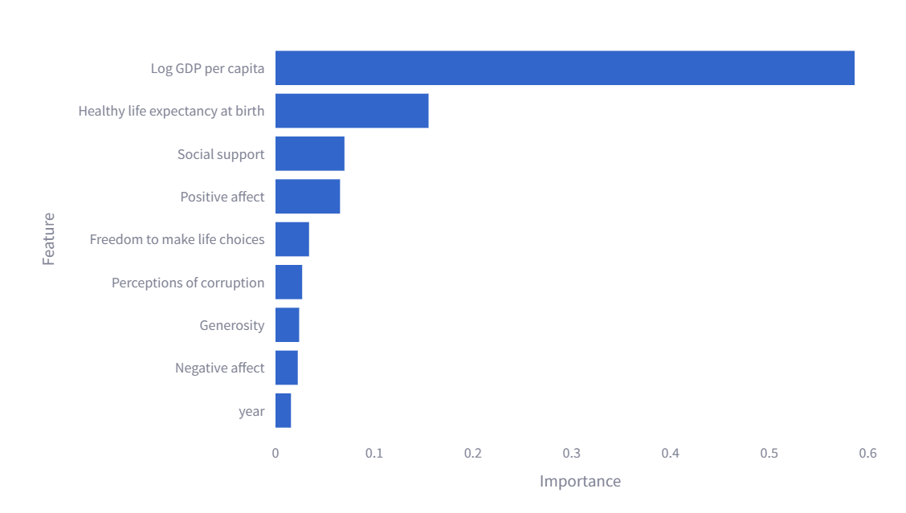

The bar chart titled "Feature Importances" shows the relative importance of various features in a predictive model or analysis. Here’s an analysis of the chart:

**Key Elements:**

1. **Axes**:
   * **X-Axis (Importance)**: Represents the importance scores of the features, ranging from 0 to approximately 0.6.
   * **Y-Axis (Feature)**: Lists the features being analyzed:
     + Log GDP per capita
     + Healthy life expectancy at birth
     + Social support
     + Positive affect
     + Freedom to make life choices
     + Perceptions of corruption
     + Generosity
     + Negative affect
     + Year
2. **Bar Lengths**:
   * The length of each bar represents the relative importance of that feature in the model.
   * Features with longer bars are more important.

**Observations:**

1. **Log GDP per capita**:
   * This feature has the highest importance score, indicating it is the most influential factor in the model.
2. **Healthy life expectancy at birth**:
   * This is the second most important feature, showing significant influence on the outcome.
3. **Social support**:
   * This feature has a moderate importance, indicating it plays a significant role, but not as much as Log GDP per capita and Healthy life expectancy at birth.
4. **Positive affect**:
   * Also shows a moderate level of importance, similar to Social support.
5. **Freedom to make life choices**:
   * Has a lower importance score compared to the top features but still contributes to the model.
6. **Perceptions of corruption, Generosity, Negative affect, Year**:
   * These features have relatively low importance scores, indicating they are less influential in the model compared to the top features.

**Insights:**

* **Economic Well-being**: The high importance of Log GDP per capita suggests that economic factors play a crucial role in the outcome being modeled, likely related to happiness or well-being.
* **Health**: The importance of Healthy life expectancy at birth indicates that health is a significant determinant of the outcome.
* **Social Factors**: Social support and positive affect are also important, emphasizing the role of social relationships and emotional well-being.
* **Freedom and Perception**: While these factors are important, they have a lesser influence compared to economic and health factors.
* **Year**: The minimal importance of the year suggests that the changes over time are not as influential as the other factors.

This chart is useful for understanding which factors are most influential in the predictive model, guiding further analysis or decision-making based on these insights.

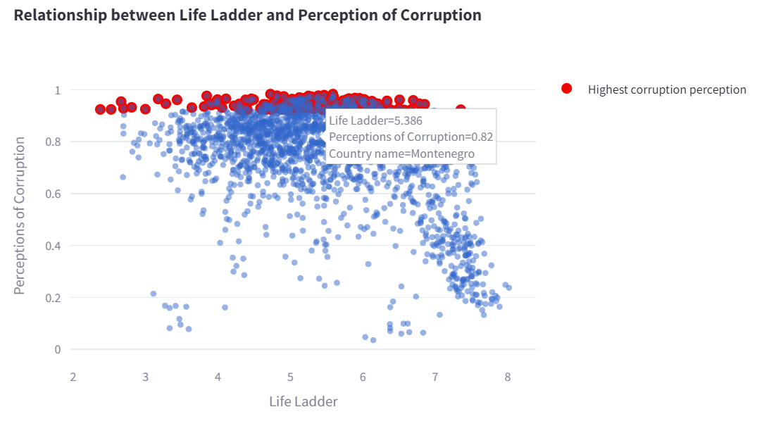

The scatter plot titled "Relationship between Life Ladder and Perception of Corruption" illustrates the correlation between happiness scores (Life Ladder) and perceptions of corruption for various countries. Here's an analysis of the key elements visible in the plot:

**Key Elements:**

1. **Axes**:
   * **X-Axis (Life Ladder)**: Represents the happiness scores, ranging approximately from 2 to 8.
   * **Y-Axis (Perceptions of Corruption)**: Represents the perceptions of corruption, ranging from 0 to 1.
2. **Data Points**:
   * Each dot represents the data for a particular country in a given year.
   * The color coding is used to highlight certain data points:
     + **Red Dots**: Represent countries with the highest perceptions of corruption.
     + **Blue Dots**: Represent other countries with varying levels of perceived corruption.
3. **Hover Information**:
   * When hovering over a data point, detailed information is displayed, including:
     + Life Ladder score
     + Perceptions of Corruption score
     + Country name

**Observations:**

1. **General Trend**:
   * There is an inverse relationship between the Life Ladder scores and perceptions of corruption.
   * Countries with higher perceptions of corruption tend to have lower Life Ladder (happiness) scores.
2. **Clusters**:
   * Most of the red dots (highest corruption perception) are clustered at the top of the chart, indicating high corruption perception scores close to 1.
   * These red dots are primarily located in the lower half of the Life Ladder scores, suggesting that high corruption perception is associated with lower happiness.
3. **Variation Among Countries**:
   * Countries with lower perceptions of corruption (blue dots) are spread across a wider range of Life Ladder scores, indicating more variability in happiness.
   * Some countries with low corruption perception still have lower Life Ladder scores, indicating that factors other than corruption also influence happiness.

**Insights:**

* **Impact of Corruption on Happiness**: The scatter plot clearly shows that higher perceptions of corruption are generally associated with lower happiness scores. This highlights the negative impact of corruption on overall well-being.
* **High Corruption Countries**: Countries with the highest perceptions of corruption (highlighted in red) predominantly show lower happiness scores, reinforcing the adverse effect of corruption on societal happiness.
* **Variability**: While corruption is a significant factor, the variability among countries with low corruption perception suggests that other factors (such as GDP, social support, health, etc.) also play crucial roles in determining happiness.

This scatter plot provides valuable insights into how perceptions of corruption correlate with happiness across different countries.

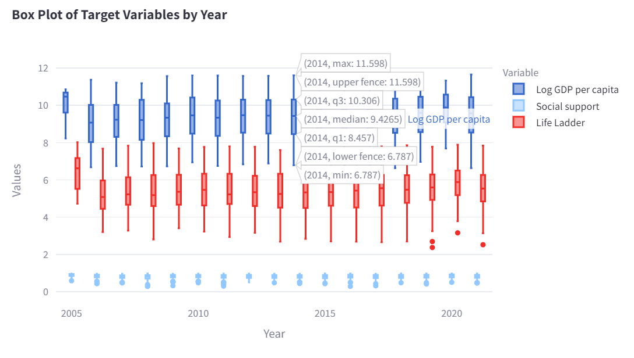

The box plot titled "Box Plot of Target Variables by Year" presents the distribution of three key variables (Log GDP per capita, Social support, and Life Ladder) over time. Here's a detailed analysis of the plot:

**Key Elements:**

1. **Axes**:
   * **X-Axis (Year)**: Represents the years ranging approximately from 2005 to 2020.
   * **Y-Axis (Values)**: Represents the values of the variables being analyzed.
2. **Variables**:
   * **Log GDP per capita** (Blue): Measures the logarithm of GDP per capita.
   * **Social support** (Light Blue): Represents the level of social support in the countries.
   * **Life Ladder** (Red): Represents the happiness scores.
3. **Box Plot Components**:
   * Each box plot shows the distribution of a variable for a particular year.
   * **Box**: The interquartile range (IQR), representing the middle 50% of the data.
   * **Whiskers**: Extend to the minimum and maximum values within 1.5 times the IQR from the lower and upper quartiles, respectively.
   * **Median Line**: The line inside the box represents the median of the data.
   * **Outliers**: Data points outside the whiskers are marked as outliers.

**Observations:**

1. **Log GDP per capita**:
   * The blue box plots indicate that the Log GDP per capita values generally range between approximately 8 and 12.
   * Over the years, the median Log GDP per capita remains relatively stable, showing slight increases or decreases.
   * The distribution remains fairly consistent, with the IQR and range showing minor variations.
2. **Social Support**:
   * The light blue box plots for social support values are clustered around a narrow range, mostly between 0.5 and 1.
   * The median values for social support show slight fluctuations but generally remain stable over the years.
   * The whiskers indicate that most data points are close to the median, with fewer outliers.
3. **Life Ladder**:
   * The red box plots for Life Ladder (happiness scores) generally range between 4 and 7.
   * The median happiness scores remain relatively consistent, with minor variations across the years.
   * The IQR and range show a stable distribution with occasional outliers.

**Insights:**

1. **Stability in Key Metrics**:
   * The box plots indicate that Log GDP per capita, social support, and happiness scores (Life Ladder) have remained relatively stable over the years.
   * The median values and IQRs do not show significant changes, suggesting consistent trends in these metrics.
2. **Distribution Patterns**:
   * The distributions for Log GDP per capita and social support are relatively tight, indicating less variability in these metrics compared to the Life Ladder.
   * Happiness scores show a broader distribution, suggesting more variability in how different countries perceive their well-being.
3. **Outliers**:
   * The presence of outliers in all three variables indicates that there are some countries with significantly different values from the majority, which could be due to various socio-economic factors.

This box plot provides a clear visual representation of how key metrics related to economic performance, social support, and happiness have evolved over time, highlighting their stability and variability across different years.

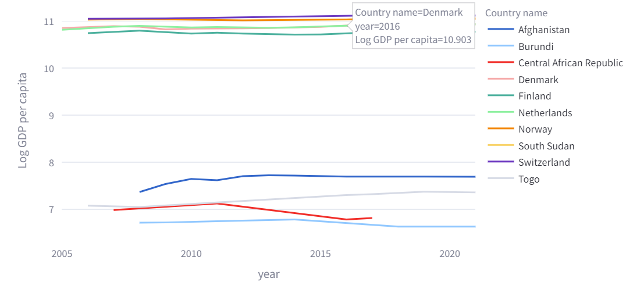

The line chart shows the "Log GDP per capita" over time for a selection of countries. Here's an analysis of the key elements visible in the plot:

**Key Elements:**

1. **Axes**:
   * **X-Axis (Year)**: Represents the years ranging from approximately 2005 to 2020.
   * **Y-Axis (Log GDP per capita)**: Represents the logarithm of GDP per capita values.
2. **Lines**:
   * Each line represents a different country, with distinct colors to differentiate them.
   * The legend on the right matches the line colors to the country names.

**Observations:**

1. **High GDP per capita Countries**:
   * **Switzerland** (purple line), **Norway** (yellow line), **Denmark** (light red line), **Netherlands** (green line), and **Finland** (aqua line) are at the top, indicating high log GDP per capita values, consistently above 10.
2. **Low GDP per capita Countries**:
   * **Afghanistan** (dark blue line), **Burundi** (light blue line), **Central African Republic** (red line), **South Sudan** (orange line), and **Togo** (grey line) are at the bottom, indicating lower log GDP per capita values, generally ranging from 7 to 8.
3. **Trends Over Time**:
   * The high GDP per capita countries (top lines) show stability or slight increases in their log GDP per capita values over time.
   * The low GDP per capita countries (bottom lines) show more variability, with some countries experiencing slight increases and others remaining stable or even declining slightly.
4. **Specific Highlights**:
   * **Denmark** (hovered line) shows a stable and high log GDP per capita around 10.903 in 2016.
   * **Afghanistan** shows a gradual increase over time, but remains below the higher GDP countries.
   * **Central African Republic** shows a slight decrease after a peak around 2010.

**Insights:**

* **Economic Stability**: The chart highlights the economic stability of high GDP per capita countries like Switzerland, Norway, Denmark, Netherlands, and Finland, which consistently have high values with minor fluctuations.
* **Economic Challenges**: Countries like Afghanistan, Burundi, Central African Republic, South Sudan, and Togo face economic challenges, reflected in their lower log GDP per capita values and more pronounced variability.
* **Global Economic Disparities**: The chart underscores the significant disparities in economic performance among different countries, with some consistently high and others struggling with lower economic outputs.

This line chart provides a clear visual representation of how the economic performance (in terms of GDP per capita) has evolved over time for various countries, highlighting both stability in high-income countries and challenges in low-income countries.

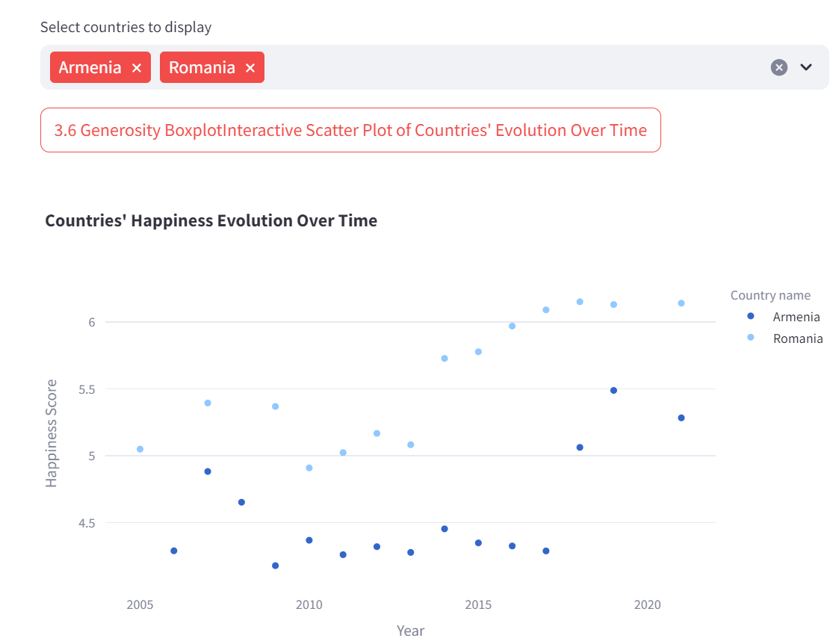

The scatter plot titled "Countries' Happiness Evolution Over Time" displays the happiness scores (Life Ladder) for Armenia and Romania over time. Here's a detailed analysis of the plot:

**Key Elements:**

1. **Axes**:
   * **X-Axis (Year)**: Represents the years from approximately 2005 to 2020.
   * **Y-Axis (Happiness Score)**: Represents the happiness scores, ranging from 4.5 to 6.
2. **Data Points**:
   * Each dot represents the happiness score for a specific year for Armenia and Romania.
   * The color coding differentiates between the two countries:
     + **Armenia** is represented by darker blue dots.
     + **Romania** is represented by lighter blue dots.
3. **Legend**:
   * The legend on the right side of the plot maps the colors to the respective country names.

**Observations:**

1. **Happiness Scores Over Time**:
   * **Armenia**:
     + The happiness scores for Armenia range from about 4.5 to 5.5 over the years.
     + There is a noticeable dip in the early 2010s, but scores generally stay around 4.5 to 5.
   * **Romania**:
     + The happiness scores for Romania range from about 5 to 6 over the years.
     + There is a gradual increase in happiness scores from around 2010 to 2020, indicating an improving trend in happiness.
2. **Comparative Trends**:
   * Romania consistently has higher happiness scores compared to Armenia throughout the period shown.
   * While Armenia's scores remain relatively stable with minor fluctuations, Romania shows a clearer upward trend, especially in the later years.

**Insights:**

* **Country Comparison**:
  + Romania exhibits higher happiness scores compared to Armenia, suggesting a relatively better perception of well-being among its citizens.
  + The upward trend in Romania's scores might reflect improvements in economic conditions, social support, or other factors contributing to happiness.
* **Trends Over Time**:
  + Armenia's stability in happiness scores suggests consistent conditions with no significant improvements or declines.
  + Romania's increasing trend might be an indication of positive changes over the years, contributing to an improved sense of happiness among its population.
* **Policy Implications**:
  + Policymakers in Armenia might need to investigate factors contributing to the stable yet lower happiness scores and explore measures to improve overall well-being.
  + Romania's positive trend could be studied to identify successful policies and practices that could be emulated by other countries aiming to improve their happiness scores.

This scatter plot effectively illustrates the evolution of happiness scores for Armenia and Romania over time, providing valuable insights into the well-being of their populations. If you need further analysis or specific insights from this data, please let me know!